

JOMO KENYATTA UNIVERSITY OF AGRICULTURE AND TECHNOLOGY.

SENTRY:

INTEGRATING A PEPPER ROBOT WITH ARTIFICIAL INTELLIGENCE FOR AUTOMATED CYBERSECURITY TRAINING

DERICK RICHARD TSUMAH: SCT212-0192/2022

BSC COMPUTER TECHNOLOGY
BCT 2406 PROJECT (YEAR 4)

SUBMISSION: 2ND MARCH, 2026

SUPERVISOR 1: DR. EUNICE NJERI
SUPERVISOR 2: PROF. WAWERU MWANGI

Abstract
Issues such as hallucinations in Large Language Models (LLMs) pose a critical barrier to deploying conversational Artificial Intelligence (AI) on social robots in important fields like cybersecurity training. In SENTRY this research investigates how exactly Retrieval-Augmented Generation (RAG) can promote grounding of responses by reducing hallucinations in LLMs deployed on the Pepper robot. We aim to implement a grounded conversational architecture on the Pepper robot for cybersecurity education, comparing baseline LLMs outputs against retrieval-augmented responses. A comparative evaluation with around 40 participants will measure grounding accuracy, hallucination rates and perceived trust.
The conducted study focuses on addressing these challenges through the integration of RAG within a Pepper-based tutoring system. The proposed grounding framework will enable the robot to retrieve domain-specific cybersecurity knowledge from curated sources such as Open Worldwide Application Security Project (OWASP) particularly their OWASP Top 10 before generating responses, thus improving factual accuracy and response traceability.
A comparative evaluation approach will be adopted in order to assess baseline generative responses against retrieval-augmented responses using grounding accuracy metrics, hallucination rate analysis and user perception measures of reliability and trust. The findings are expected to demonstrate how retrieval grounding mechanisms can enhance the reliability of embodied AI tutors and contribute to the development of trustworthy social robotics systems for educational environments.

Contents
Abstract 2
1.1 Motivation / Background 5
1.1.1 Overview 5
1.1.2 Vision 5
1.1.3 Social Impact 6
1.2 Statement of the Problem / Opportunity 7
1.3 Proposed Solution 8
1.3.1 Description 8
1.3.2 Area of Research 10
1.3.3 Tools and Technologies 10
1.4 Objectives 11
1.4.1 Main Objective 11
1.4.2 Specific Objectives 11
2. STATE OF THE ART 13
2.1 Literature Summary 13
2.2 Existing Examples / Literature 15
2.2.1 Social Robots in Educational Contexts 15
2.2.2 Trust and Reliability in Human-Robot Interaction 16
2.2.3 Grounded and Retrieval-Augmented Generative Systems 16
2.3 Gaps in Identified Literature 18
2.4 Emerging Trends 20
2.5 Conclusion 21
3. APPROACH / METHODOLOGY 23
3.1 Description 23
3.2 Technologies 27
3.3 Data 28
3.4 Evaluation / Testing / Validation 29
3.5 Expected Outcomes 30
3.6 Ethical Considerations 31
3.6.1 Ethical Risks and Concerns 31
3.6.2 Ethical Mitigation Measures 31
4. Conclusion 33
5. References 35
APPENDICES 37
Appendix 1: Plan and Timeline 37
Appendix 1: Budget 39

1. INTRODUCTION

1.1 Motivation / Background

1.1.1 Overview
SENTRY (Integrating a Pepper Robot with Artificial Intelligence for Automated Cybersecurity Training) is a multidisciplinary computing project that aims to explore the use of socially interactive robotics as an intelligent tutoring platform for the cybersecurity education. It integrates embodied robotics, conversational artificial intelligence and domain-specific knowledge systems to deliver structure scenario-based cybersecurity training sessions.
Research demonstrates that socially assistive robots enhance engagement and learning outcomes in educational contexts (Belpaeme et al., 2018). By introducing a physical humanoid robot (Pepper) into cybersecurity instruction, SENTRY aims to extend these benefits into a technically demanding domain that traditionally relies on static or screen-based learning environments. The system will be designed to simulate real-world cybersecurity scenarios through dialogue-driven sessions, combining speech interaction, gesture support and contextualized responses to create and immersive and applied experience.
This component focuses on the Generative AI Grounding and Integration, which ensures that conversational responses generated by the Pepper robot remain accurate, verifiable and aligned with cybersecurity training objectives.

1.1.2 Vision
Large Language Models now power conversational systems in education and human-robot interaction. These models demonstrate strong generative performance across diverse tasks (Brown et al., 2020), enabling dynamic explanations and adaptive dialogue. But research has also highlighted the vulnerability of such models to producing fabricated or unsupported information that is referred to as hallucinations (Ji et al., 2023). When deployed in embodied robotic systems, these limitations become especially critical as inaccuracies may directly affect user trust and perceived credibility of the system.
The vision behind SENTRY is to develop a trustworthy grounded AI-powered robotic tutor capable of delivering structured training, in this case, cybersecurity while maintaining factual reliability. The motivation stems from the growing demand for innovative cybersecurity education and the need to ensure that AI-driven instructional systems operate transparently and responsibly.

1.1.3 Social Impact
Cybersecurity has become a national and global priority due to the increasing frequency of digital attacks affecting businesses, governments and individuals. And so developing cybersecurity awareness and practical skills is therefore not only an academic concern but also a societal necessity. Traditional training approaches often rely only on passive content delivery methods, which may not sufficiently engage learners or simulate authentic threat scenarios in the current world societal state.
SENTRY addresses this gap by introducing an interactive robotic tutor capable of presenting dynamic cybersecurity scenarios that reflect real-world challenges. The use of an embodied system enhances learner engagement while retrieval-based grounding ensures that information presented during sessions is derived from curated and up-to-date domain knowledge sources.
In the context of national development and digital transformation initiatives, projects that combine artificial intelligence, robotics and cybersecurity education contribute to building technical capacity and digital resilience. So, by focusing on reliability, transparency and trust, SENTRY supports the responsible deployment of AI-driven educational technologies within community and institutional environments.

1.2 Statement of the Problem / Opportunity
The integration of Large Language Models (LLMs) into social robots presents a fundamental reliability challenge. While LLMs enable fluid and context-aware dialogue, they are inherently probabilistic systems that may generate factually incorrect, outdated or unverified responses -hallucinations. In conventional text-based applications, these limitations may be manageable through disclaimers or post-hoc verification but in embodied robotic systems used for instructional purposes, inaccurate responses can directly undermine user trust, reduce instructional credibility and compromise learning outcomes.
This challenge is particularly significant in cybersecurity education where precision and accuracy are very critical. A tutoring robot that delivers incorrect explanations of vulnerabilities, misrepresents attack mitigation strategies or provides outdated procedural guidance risks reinforcing misinformation rather than improving learner competence. The problem so goes beyond conversational fluency; it concerns the alignment between generative AI outputs and verifiable domain knowledge within real-time interactive systems.
Existing conversational robotics systems often rely either on static rule-based dialogue management or unconstrained generative models. Rule-based systems offer reliability but lack flexibility and scalability. Purely generative systems provide adaptability but introduce unpredictability and hallucination risks. There remains a gap in designing architectures that preserve conversational flexibility while ensuring grounded, verifiable and contextually appropriate responses in embodied tutoring environments.
The core problem addressed is therefore the development of a computing architecture that enables grounded generative dialogue within Pepper-based cybersecurity tutoring robot, reducing hallucination while maintaining interactive quality and user trust.

1.3 Proposed Solution

1.3.1 Description
We propose the development of SENTRY, a AI-powered cybersecurity tutoring system implemented on the Pepper humanoid robot. Where the system integrates structured scenario-based instruction with grounded generative conversational capabilities to deliver interactive cybersecurity training sessions.
Timothy Wachira (teammate) leads the Human-Robot Interaction layer while my role focuses on the integration of a Retrieval-Augmented generation (RAG) framework into the conversational architecture of a Pepper-based social tutoring robot. The objective is to enhance response reliability, grounding accuracy and perceived trust during Human-Robot Interaction in an educational context.
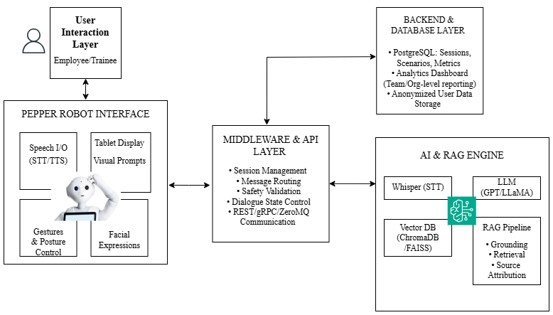
The system operates through three coordinated functional components:
- Scenario and Interaction Management Module:
This governs the flow of the cybersecurity training sessions. Shown in the diagram via the User Interaction Layer and Pepper Robot Interface Layer. Learning content is organized into predefined scenarios and dialogue state machines regulate transitions between instructional phases, user prompts and feedback mechanisms. Pepper’s speech synthesis, gesture coordination and tablet interface are controlled to ensure coherent and structured human-robot interaction.
- Generative AI Grounding and Integration Module:
This module enhances Pepper’s conversational intelligence by integrating a retrieval mechanism with a large language model. Shown in the diagram via the AI and RAG Engine layer. When a learner poses a query, the system retrieves semantically relevant content from a curated knowledge base before generating a response. Retrieved passages are incorporated into the model’s prompt, constraining output generation to domain-relevant information. This reduces reliance on static model parameters and mitigates the risk of hallucinated or unsupported responses.
This module connects the retrieval engine, language model and Pepper’s internal framework, enabling real-time grounded dialogue during tutoring sessions.
- Management Module:
This manages domain-specific cybersecurity materials used for retrieval. Shown by the Backend and Database Layer. Documents are pre-processed, embedded into vector representations and stored within a semantic database to enable similarity-based querying. The modular separation between knowledge storage and response generation allows this system to incorporate updated cybersecurity content without retraining the underlying language model in use.
All these are connected via the Middleware and API layer for communication and effective flow. Through this architecture, SENTRY maintains structures instructional control while enabling adaptive, context-aware and verifiable conversational interaction.

1.3.2 Area of Research
The project is positioned at the intersection of multiple computing research domains:
- Human-Robot Interaction (HRI): Focused on trust, usability and reliability in embodied conversational agents.
- Machine Learning (ML) and Natural Language Processing (NLP): Emphasizing large language models and retrieval-augmented generation architectures.
- Robotics Systems Integration: Addressing middleware coordination between AI services and physical humanoid robotic platforms.
- Cybersecurity Education Technology: Concentrating on scenario-based learning and applied technical skill development.
By combining these domains, the project contributes to research in trustworthy AI systems for embodied educational environments.

1.3.3 Tools and Technologies
The implementation will utilize the Pepper humanoid robot as the physical interaction platform, controlled through the NAOqi development framework for speech, gesture and tablet interface coordination.
The conversational intelligence layer incorporates:
- A larger language model accessed via API for dynamic response generation (like GPT-4).
- A semantic retrieval pipeline that transforms curated cybersecurity documents into vector embeddings.
- A vector database (such as ChromaDB) to enable similarity-based knowledge retrieval.
- Middleware services implemented in Python to integrate retrieval, generation and robot interaction components.
This combination will support real-time grounding dialogue while maintaining modularity between interaction control, knowledge management and generative processing.

1.4 Objectives

1.4.1 Main Objective
The aim is to investigate, design, develop and evaluate a grounded conversational architecture that integrates Retrieval-Augmented Generation (RAG) within a Pepper-based cybersecurity tutoring system in order to improve response reliability, reduce hallucinations and enhance user trust in human-robot interaction.

1.4.2 Specific Objectives
- To investigate existing retrieval augmented techniques in human-robot interaction frameworks to derive system requirements for grounded cybersecurity tutoring.
  - Analyse current implementations of LLMs in socially interactive robotic systems, focusing on documented reliability limitations and hallucination behaviour instructional contexts.
  - Examine existing RAG approaches and architectural patterns used to constrain generative responses in domain-specific applications.
  - Synthesize findings to define functional and non-functional requirements for a scenario-driven, retrieval-enhanced conversational tutoring system.
- To design a scenario-driven conversational architecture that integrates semantic retrieval with a LLM model withing the Pepper robotic platform.
  - Define structured cybersecurity tutoring scenarios and dialogue state transitions to regulate interaction flow and progression.
  - Design a semantic retrieval pipeline that embeds curated cybersecurity documents into vector representations for similarity-based querying.
  - Specify middleware interfaces that coordinated query processing, retrieval augmentation, response generation and Pepper’s interaction framework.
- To develop and implement the proposed grounded conversational system using the NAOqi framework, a vector database and API-based language model integration.
  - Implement scenario management and interaction control using the NAOqi SDK for speech, gesture and tablet interface coordination.
  - Develop the retrieval engine and integrate a vector database to support real-time knowledge grounding.
  - Integrate the retrieval pipeline with the language model and establish an end-to-end communication flow between Pepper and the grounding module.
- To evaluate the effectiveness of the proposed architecture in improving reliability and user trust during cybersecurity tutoring sessions.
  - Conduct comparative testing between baseline generative responses and retrieval-augmented responses under controlled scenario conditions.
  - Measure grounding accuracy and hallucination rate using defined quantitative metrics.
  - Assess user perception of reliability, clarity and trust through structured usability instruments and interaction feedback analysis.

2. STATE OF THE ART

2.1 Literature Summary
Recent advances across social robotics, trustworthy artificial intelligence and knowledge-grounded language modelling have created a fertile but underexplored intersection for embodied conversational systems. While each field has progressed substantially, systematic integration of grounding mechanisms within educational social robots remains limited.
Research in social robotics demonstrates that embodied agents can enhance engagement, motivation and perceived social presence in learning environments. Belpaeme et al. (2018) synthesised findings across language learning and STEM education, concluding that embodiment positively influences learner engagement but requires adaptive interaction to sustain long-term effectiveness. Subsequent studies emphasize personalization and interactional contingency as essential components of robotic tutoring systems (Ahmad et al., 2016). However, most deployed systems rely on rule-based dialogue management or fixed knowledge structures, restricting their ability to dynamically retrieve domain-specific information in knowledge-intensive subjects such as cybersecurity.
Cybersecurity education, in particular, presents unique challenges. It is a rapidly evolving, technically dense domain where factual precision is critical. Errors or fabricated explanations can reinforce misconceptions or undermine trust. As cybersecurity awareness becomes a national and global priority (ENISA, 2023; NIST, 2023), the need for reliable and adaptive tutoring systems becomes increasingly important. Yet current robotic tutoring implementations have not sufficiently addressed mechanisms for ensuring factual grounding in such dynamic domains.
In parallel to developments in robotics, research in Human-Robot Interaction (HRI) has extensively examined trust formation. Reliability and performance consistency remain among the strongest predictors of user trust (Hancock et al., 2011). Studies further demonstrate that repeated performance failures significantly degrade trust, even when robots display socially engaging behaviours (Salem et al., 2015). These findings indicate that perceived competence often outweighs social expressiveness in sustained interaction. However, most trust research predates the widespread deployment of large language models in embodied systems and does not explicitly address hallucination risks introduced by generative AI.
The emergence of large language models (LLMs) has significantly expanded conversational capabilities but introduced challenges related to hallucination and factual inconsistency. Ji et al. (2023) provide a comprehensive survey categorizing hallucinations in natural language generation and identifying insufficient grounding as a primary cause. To mitigate this, grounding approaches such as Retrieval-Augmented Generation (RAG) (Lewis et al., 2020), external knowledge integration and post-generation verification mechanisms have been proposed. RAG architectures combine dense vector retrieval with generative decoding, allowing models to condition responses on retrieved documents rather than relying solely on parametric memory. Empirical studies demonstrate improved factual accuracy in knowledge-intensive tasks compared to standalone generative models.
Despite these advances, integration of grounding techniques into embodied social robots remains sparse. Recent trends indicate increasing convergence between foundation models and robotics, where large language models are incorporated into robotic planning and dialogue systems. However, systematic architectural frameworks that combine retrieval pipelines, semantic embedding models, middleware coordination and robotic interaction frameworks (e.g., NAOqi) are still emerging. Furthermore, limited empirical research has examined how grounding mechanisms influence perceived trust, reliability and interaction quality in educational Human-Robot Interaction settings.
Collectively, the literature suggests that while social robotics enhances engagement and retrieval-augmented generative models improve factual reliability, their integration; particularly within cybersecurity tutoring contexts, remains underexplored. This intersection forms the conceptual foundation for the present study, which investigates how retrieval-based grounding and structured integration within an embodied robotic platform can enhance response reliability and user trust.

2.2 Existing Examples / Literature

2.2.1 Social Robots in Educational Contexts
Belpaeme et al. (2018) provide one of the most comprehensive reviews of social robots in education, synthesizing empirical deployments across language learning, mathematics and collaborative problem-solving. Their analysis highlights three consistent design principles: (1) embodiment enhances engagement, (2) long-term interaction requires adaptive behaviour and (3) pedagogical effectiveness depends on structured interaction scaffolding. Importantly, many systems reviewed rely on carefully scripted dialogue models or finite-state interaction flows. From a systems perspective, these implementations demonstrate the importance of scenario control and structured pedagogical sequencing; an insight directly relevant to the scenario-driven conversational architecture proposed in this project. However, the reviewed systems largely avoid open-ended generative dialogue due to reliability concerns, thereby limiting scalability in knowledge-dense domains.
Going back a bit further for context, Tanaka et al. (2007) conducted a longitudinal field study in which children interacted with a robotic peer for vocabulary learning over several months. The study provides methodological insight into long-term deployment evaluation, including retention measurement and behavioural observation metrics. The system architecture, however, was constrained to predefined lesson content and did not incorporate dynamic retrieval or external knowledge sources. This highlights a central trade-off in educational robotics: stability through scripting versus adaptability through dynamic knowledge access.
Kennedy et al. (2015) then examined long-term child-robot interaction and emphasized personalization and memory of prior interactions as key factors in sustained engagement. The system incorporated user modelling to adjust behaviour over time. While personalization improved interaction quality, knowledge delivery remained bounded by static instructional content. From an architectural standpoint, these works underscore the value of structured dialogue management and state tracking but reveal the absence of scalable knowledge-grounding pipelines.
Collectively, educational robotics research provides validated interaction frameworks, scenario control, personalization, adaptive scaffolding, yet lacks integration with retrieval-based generative models capable of dynamically accessing evolving knowledge domains such as cybersecurity.

2.2.2 Trust and Reliability in Human-Robot Interaction
Trust research in HRI provides strong theoretical grounding for evaluating reliability in embodied systems. Hancock et al. (2011) identify performance reliability as the dominant predictor of trust across domains. Their meta-analysis establishes quantitative effect sizes linking system error rates to user trust perceptions. This provides a measurable foundation for evaluating improvements in conversational reliability within this project.
Salem et al. (2015) experimentally demonstrate that repeated robot errors significantly reduce compliance and trust, even when robots maintain socially expressive behaviours. This finding is particularly relevant when considering generative AI integration: linguistic fluency does not compensate for factual inaccuracies. For conversational tutoring systems, epistemic errors may be more damaging than mechanical task failures.
De Visser et al. (2018) extend trust research by introducing the concept of trust calibration; aligning user trust with actual system capability. Over-trust can be as dangerous as under-trust, particularly in safety-critical or knowledge-critical domains. In the context of generative conversational robots, hallucinated but confidently delivered responses risk inducing inappropriate trust calibration. This insight directly motivates the need for explicit grounding mechanisms and potentially source attribution within generated responses.
Despite these advances, most empirical trust studies evaluate navigation errors, task execution failures or behavioural transparency rather than knowledge fabrication in language models. As large language models are integrated into robotic dialogue systems, the primary reliability risk shifts from physical performance to informational correctness. This epistemic shift remains insufficiently addressed in embodied HRI literature.

2.2.3 Grounded and Retrieval-Augmented Generative Systems
In natural language processing research, grounding mechanisms have been developed to address hallucination in generative models. Lewis et al. (2020) introduced Retrieval-Augmented Generation (RAG), integrating Dense Passage Retrieval with sequence-to-sequence transformers. The architecture separates parametric knowledge (model weights) from non-parametric memory (external documents), enabling responses to be conditioned on retrieved evidence. Empirical evaluation on open-domain question answering benchmarks demonstrates improved factual accuracy compared to purely parametric baselines.
Karpukhin et al. (2020) proposed Dense Passage Retrieval (DPR), which uses dual-encoder transformer architectures to generate dense vector embeddings for semantic similarity search. DPR enables efficient large-scale retrieval and forms the backbone of many RAG pipelines. Architecturally, DPR introduces the embedding-retrieval-generation flow that this project adopts within a robotic middleware environment.
Borgeaud et al. (2022) introduced RETRO (Retrieval-Enhanced Transformer), demonstrating that large language models augmented with retrieval can outperform significantly larger parametric models while reducing hallucination. This work reinforces the principle that external grounding reduces reliance on memorized parameters.
Ji et al. (2023) provide a systematic taxonomy of hallucination types and mitigation strategies, emphasizing retrieval-based conditioning and post-generation verification as primary solutions. Importantly, the majority of empirical evaluations occur in static text-based settings rather than embodied interactive environments.
While recent robotics research has begun integrating large language models for planning and dialogue, most implementations either rely on direct API-based generation without grounding or use constrained prompting strategies. There is limited work systematically combining semantic retrieval, vector databases, middleware orchestration and embodied tutoring evaluation within a single controlled architecture.
From a systems integration perspective, the gap lies not in the existence of retrieval-based generation but in its structured deployment within a robotic tutoring framework, including scenario control, latency management and trust evaluation.

2.3 Gaps in Identified Literature
The reviewed literature reveals substantial progress in social robotics, trust modelling and retrieval-augmented generation independently. However, several critical gaps remain at their intersection, particularly in the context of knowledge-intensive educational domains such as cybersecurity.
- Educational social robots predominantly rely on scripted dialogue management systems or static instructional databases.
While these approaches enhance interaction stability and pedagogical control (Belpaeme et al., 2018; Tanaka et al., 2007), they limit dynamic knowledge adaptability. In rapidly evolving domains like cybersecurity, static content structures risk obsolescence and restrict responsiveness to scenario-driven or open-ended queries. This limitation directly motivates the investigation and design objectives of this project, which aim to incorporate real-time retrieval mechanisms into structured tutoring scenarios.
- Personalization and adaptive behaviours in educational robots have largely focused on social and behavioural adaptation rather than epistemic reliability.
Existing frameworks emphasize engagement, memory of prior interactions and affective alignment (Kennedy et al., 2015), yet they do not address the correctness of dynamically generated knowledge. This creates a distinction between behavioural adaptation and informational grounding; a distinction central to the proposed integration of retrieval-augmented generation within the tutoring architecture.
- Trust research in Human–Robot Interaction identifies reliability as a dominant predictor of trust (Hancock et al., 2011; Salem et al., 2015)
Yet most empirical evaluations focus on mechanical task errors or behavioural transparency rather than knowledge fabrication risks introduced by large language models. The emergence of generative AI shifts the primary source of reliability risk from physical execution failure to epistemic error. There is limited empirical investigation into how hallucinated responses affect trust calibration in embodied conversational systems. Addressing this shift directly aligns with the evaluation objective of this project, which examines whether grounding mechanisms measurably influence perceived reliability and trust.
- Retrieval-augmented generation architectures such as RAG and Dense Passage Retrieval have demonstrated improved factual accuracy in text-based benchmarks (Lewis et al., 2020; Karpukhin et al., 2020).
But these systems are typically evaluated in static question-answering environments without embodiment, real-time interaction constraints or multimodal coordination. There is limited research examining how retrieval latency, dialogue state management and middleware orchestration affect performance within robotic platforms such as Pepper. This architectural integration gap directly relates to the design and development objectives of this study.
- While recent research trends indicate growing convergence between foundation models and robotics, implementations often rely on direct API-based language model calls without structured grounding pipelines or controlled scenario management.
Such integrations prioritize fluency and flexibility but do not systematically evaluate hallucination reduction or trust outcomes in tutoring contexts. Consequently, there remains a lack of empirically validated frameworks that combine structured dialogue scenarios, semantic retrieval pipelines and embodied interaction evaluation within a single system.
- Limited research has examined grounding within domain-specific tutoring contexts that demand factual precision, such as cybersecurity education.
Knowledge-intensive domains introduce higher stakes for misinformation, making grounding mechanisms not merely an optimization strategy but a reliability requirement. The absence of domain-focused evaluations further justifies the contextual framing of this project.
Collectively, these gaps reveal a missing architectural and empirical bridge between retrieval-augmented generative AI and embodied educational robotics. The literature demonstrates that engagement frameworks exist, grounding techniques exist and trust models exist; yet their systematic integration and evaluation within a knowledge-sensitive robotic tutoring environment remains underexplored.
This project aims to address these gaps by designing and implementing a structured, retrieval-augmented conversational architecture within a Pepper-based cybersecurity tutoring system and by empirically evaluating its impact on response reliability and perceived trust.

2.4 Emerging Trends
Recent research indicates a growing convergence between large-scale foundation models and embodied robotic systems. Advances in large language models have enabled robots to perform increasingly complex dialogue, reasoning and task planning functions. However, early integrations often rely on direct prompt-based access to language models without structured grounding or architectural constraints, raising concerns about reliability and hallucination in real-world deployments.
Simultaneously, trustworthy AI research has shifted toward explicit grounding, verification and hybrid architectures that combine parametric learning with non-parametric memory. Retrieval-based systems, vector databases and semantic embedding pipelines are increasingly adopted to reduce hallucination and improve traceability of generated responses. Rather than relying solely on internal model parameters, modern architectures emphasize external knowledge conditioning and modular system design.
Another significant trend is the move toward hybrid AI systems that integrate retrieval, reasoning and generation within coordinated pipelines. Such systems separate responsibilities across components: embedding models handle semantic similarity, retrieval modules access curated knowledge and generative models produce natural language output conditioned on retrieved evidence. This modularity improves interpretability, scalability and adaptability across domains.
In robotics, there is growing emphasis on human-centered design, long-term deployment evaluation and trust calibration. Researchers increasingly recognize that user perception of competence depends not only on behavioural expressiveness but also on informational reliability. As conversational AI becomes embedded within physical systems, the need for epistemic accountability, clear grounding and controlled generation, becomes central to safe and credible human-robot interaction.
Collectively, these trends suggest a shift away from monolithic generative systems toward structured, retrieval-enhanced and evaluation-driven architectures. Extending such hybrid grounding mechanisms into embodied educational robotics represents a logical and timely progression of current research trajectories.

2.5 Conclusion
The reviewed literature demonstrates substantial advancements in social robotics, trust modelling in Human-Robot Interaction and retrieval-augmented generative AI. Educational robots have shown measurable benefits in engagement and motivation, yet most rely on scripted dialogue systems that constrain knowledge adaptability. Trust research consistently identifies reliability as a core determinant of user acceptance but has not fully addressed epistemic risks introduced by generative language models. Meanwhile, retrieval-augmented architectures have proven effective in improving factual consistency in text-based AI systems but remain insufficiently integrated within embodied robotic platforms.
A clear interdisciplinary gap emerges at the intersection of these domains. There is limited empirical investigation into how structured grounding mechanisms, such as semantic retrieval pipelines integrated with large language models, influence reliability and user trust within embodied tutoring contexts; particularly in knowledge-intensive domains like cybersecurity.
This project responds directly to that gap by designing and implementing a retrieval-augmented conversational architecture within a Pepper-based tutoring system and empirically evaluating its impact on response grounding and perceived trust. By integrating structured scenario control, semantic retrieval and generative response conditioning within an embodied platform, the study contributes to the emerging convergence between trustworthy AI and social robotics.
In doing so, it positions grounding not merely as a technical enhancement, but as a foundational requirement for reliable and credible human-robot educational interaction.

3. APPROACH / METHODOLOGY

3.1 Description
The study adopts a Design Science Research (DSR) methodology combined with controlled empirical evaluation. Design Science Research is appropriate because the project aims to construct, implement, and evaluate a retrieval-augmented conversational architecture embedded within a Pepper robotic tutoring system.
The methodology integrates system engineering, experimental comparison, and user-centred validation. The development process follows an iterative, modular approach structured into six phases:
Phase 1: Requirements Analysis and Problem Scoping
This phase defines functional and non-functional system requirements derived from the literature review and project objectives.
Activities include:
- Identifying cybersecurity tutoring scenarios aligned with knowledge-intensive risk categories (like phishing, password security, social engineering).
- Defining measurable reliability criteria (hallucination reduction, grounding traceability).
- Analysing Pepper’s hardware and OS constraints (NAOqi 2.5, Python 2.7 dependency, limited onboard compute capacity).
- Establishing evaluation metrics aligned with trust and reliability constructs identified in HRI research.
The output is formal requirements specification and evaluation framework.
Phase 2: System Architecture Design
A modular architecture will be designed to separate interaction control from AI computation.
The system will consist of:
- Pepper interaction layer (speech, gestures, tablet display)
- Middleware bridge (inter-process communication layer
- AI backend server (LLM + RAG pipeline)
- Vector database for semantic retrieval
- Curated cybersecurity knowledge base
The design will explicitly implement a retrieval-conditioning-generation flow, ensuring that generative responses are contextually constrained by retrieved documents.
Latency thresholds (< 3-5 seconds response time) will be defined to maintain conversational naturalness.
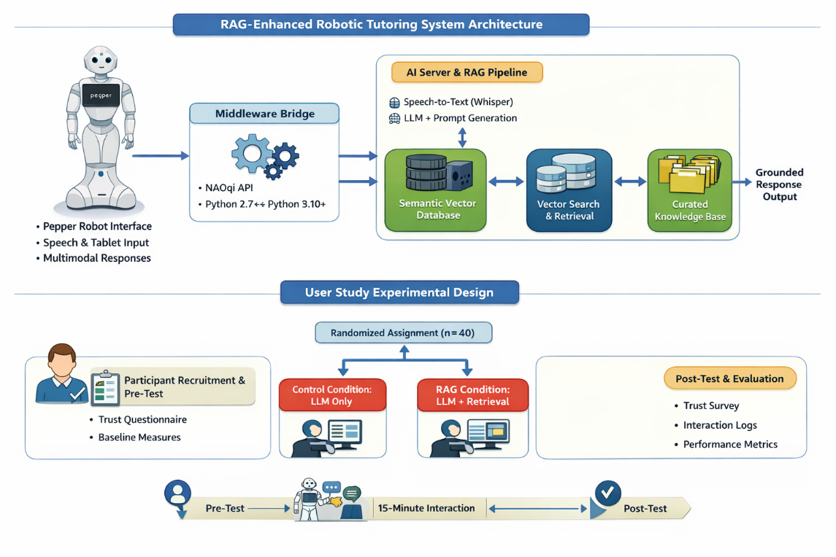
Phase 3: RAG Pipeline and Knowledge Base Development
This phase operationalizes grounding.
Steps include:
- Knowledge Curation
  - OWASP Top 10 documentation
  - Public vulnerability advisories (CVE summaries)
  - Cybersecurity awareness guidelines
  - Kenyan Computer Misuse and Cybercrimes Act (2018)
- Preprocessing
  - Text segmentation into semantically coherent chunks
  - Metadata tagging (risk level, attack type, difficulty level)
  - Cleaning and normalization
- Embedding and Indexing
  - Sentence-transformer embeddings (all-MiniLM)
  - Vector indexing using ChromaDB
  - Cosine similarity ranking for top-k retrieval
- Retrieval-Augmented Generation
  - Query embedding
  - Top-k document retrieval
  - Prompt construction that injects retrieved context
  - Constrained generation using system-level grounding instructions
This structure directly implements the RAG paradigm described by Lewis et al. (2020), adapted for embodied interaction.
The Output: Fully functional retrieval pipeline integrated with LLM.
Phase 4: Integration and Middleware Development
Due to Pepper’s dependency on Python 2.7 (NAOqi SDK), a middleware bridge will coordinate communication with a Python 3.x backend server.
Implementation includes:
- REST or gRPC interface between Pepper and backend
- JSON-based structured message exchange
- Asynchronous request handling to manage latency
- Error-handling and fallback logic for retrieval failure
Speech-to-text processing will be performed using Whisper, with transcription passed to the retrieval pipeline.
Multimodal responses will include:
- Spoken response
- Tablet-based source attribution
- Optional visual citation display
Output: End-to-end integrated robotic tutoring system.
Phase 5: Evaluation and User Study
A controlled comparative evaluation will be conducted.
Design:
Between-subjects randomized controlled experiment
- Control condition: LLM without retrieval grounding
- Experimental condition: RAG-enhanced system
Participants: Roughly 40 individuals (20 per group)
Procedure:
- Pre-interaction questionnaire (baseline trust disposition)
- 15-minute structured tutoring session
- Post-interaction trust and reliability survey
- Interaction log analysis
Objective measurements:
- Hallucination rate (expert annotation against curated sources
- Grounding accuracy (claim traceability)
- Response latency
- Engagement metrics
Subjective measurements:
- Perceived trust
- Perceived competence
- Perceived reliability
Statistical tests:
- Independent samples t-test
- Effect size calculation (Cohen’s d)
- Chi-square test for categorical trust responses.
Phase 6: Documentation and Reporting
Includes:
- Technical documentation
- Dataset preparation (anonymized logs)
- Statistical analysis report
- Architecture publication-ready diagram
- Code repository (modularized)

3.2 Technologies
Hardware
- SoftBank Robotics Pepper (NAOqi OS 2.5, Intel Atom E3845, 4GB RAM)
- External GPU-enabled workstation for model inference
Software Frameworks
- NAOqi SDK (Python 2.7)
- Python 3.10+ backend
- FastAPI for server framework
- ChromaDB for vector similarity search
- Sentence-Transformers for embeddings
- Whisper (speech-to-text)
- GPT-4 API for generation
Algorithms and Techniques
- Dense vector retrieval (DPR-inspired architecture)
- Cosine similarity scoring
- Top-k retrieval ranking
- Prompt conditioning with context injection
- Statistical hypothesis testing
Reference foundations:
- Lewis et al. (2020): Retrieval-Augmented Generation
- Karpukhin et al. (2020): Dense Passage Retrieval

3.3 Data
Primary Data:
Collected during interaction sessions:
- Anonymized participant ID
- Scenario type
- Transcribed queries
- Generated responses
- Retrieved document IDs
- Response time
- Trust survey responses
No raw audio retained.
Secondary Data:
- OWASP Top 10 (official documentation)
- Public CVE database summaries
- Kenyan Computer Misuse and Cybercrimes Act (2019)
- Cybersecurity awareness materials
Preprocessing:
- Cleaning
- Chunking
- Embedding
- Vector indexing

3.4 Evaluation / Testing / Validation
Testing Procedures:
- Functional Testing: Verify scenario execution, response appropriateness, data logging
- Integration Testing: Test Pepper-server-AI-database communication, real-time response handling
- User Testing: Pilot study with small participant group, observe interaction flow, collect feedback
Evaluation Metrics:
- Hallucination Rate: Proportion of incorrect/unverifiable responses (expert-annotated)
- Grounding Accuracy: Percentage of claims traceable to retrieved documents
- Perceived Trust: Composite score from validated scales (Salem et al., 2015)
- Response Latency: End-to-end time from input to response
- Engagement Metrics: Session completion rate, dialogue length, source verification behaviour
User Study Design:
Between-subjects randomized controlled trial with 40 participants (20 per condition). Pre-test questionnaire, 15-minute interaction session, post-test questionnaire measuring trust and perceived reliability.

3.5 Expected Outcomes
Deliverables:
- Functional Pepper-based tutoring system with RAG integration
- Comparative evaluation dataset with annotated interaction logs
- Technical architecture documentation and API specifications
- Evaluation report with statistical analysis
- Source code repository with modular components
Contributions:
- First empirical evaluation of RAG effectiveness in real-time embodied HRI
- Novel architecture for Python 2.7/3.x interoperability in legacy robotic platforms
- Evidence-based framework for trustworthy AI tutoring in high-stakes domains
Real-World Applications:
- Corporate cybersecurity training programs
- Government digital literacy initiatives
- NGO training workshops
- Replicable architecture for other educational domains (health, legal compliance)

3.6 Ethical Considerations

3.6.1 Ethical Risks and Concerns
The project identifies the following ethical considerations associated with the development and deployment of an AI-driven social tutoring robot:
Privacy: Collection of interaction data including voice recordings, query logs and behavioral metrics raises concerns regarding biometric data privacy and potential re-identification of participants from interaction patterns.
Trust: Users may develop over-reliance on AI-generated advice, leading to automation bias where critical evaluation of information is suspended. This is particularly concerning in educational contexts where incorrect guidance could propagate misinformation.
Bias: Language models and speech recognition systems may exhibit bias against certain accents, dialects or demographic groups. The cybersecurity domain knowledge may also assume technical backgrounds that disadvantage non-technical users.
Psychological Impact: Simulated cybersecurity attack scenarios (e.g., phishing simulations) may induce stress, anxiety or negative emotional responses in participants, particularly if presented with high realism without appropriate framing.
Economic Impact: Deployment of automated tutoring systems may raise concerns regarding displacement of human educators or unequal access to advanced AI-driven training tools across resource-constrained organizations.

3.6.2 Ethical Mitigation Measures
To address these concerns, the following measures will be implemented:
Data Anonymization: All user data will be anonymized using cryptographic hashing techniques. No personally identifiable information (names, employee IDs, contact details) will be stored in research databases.
Minimal Data Collection: Only data essential for research objectives will be collected. Raw audio recordings will be processed in real-time and immediately discarded; only transcribed text and interaction metadata will be retained.
Informed Consent: All participants will provide written informed consent before participation, clearly explaining the nature of data collection, storage procedures, retention periods and their right to withdraw without penalty.
Response Grounding: AI responses will be grounded using verified documents from curated knowledge sources. The system will explicitly indicate when information is retrieved versus generated and source attribution will be displayed on Pepper's tablet to enable user verification.
Content Limitations: The system will avoid providing legal advice or definitive security recommendations. All explanations will be factual, educational and framed as guidance rather than instruction. Critical security decisions will be flagged for human expert review.
Bias Mitigation: Speech recognition models will be validated on diverse accent samples. System content will be reviewed for cultural appropriateness and technical accessibility. Multiple difficulty levels will accommodate varying user backgrounds.
Psychological Safeguarding: Simulated attack scenarios will be clearly labelled as educational exercises. Participants will be debriefed after sessions and stress indicators will be monitored. Immediate cessation protocols will be available if participants experience discomfort.
Regulatory Compliance: Data handling will comply with the Kenya Data Protection Act (2019). Institutional ethical approval will be obtained prior to participant recruitment. Regular audits will ensure ongoing compliance with data protection principles.

4. Conclusion
This proposal presented the design and evaluation of a RAG-enhanced robotic tutoring system aimed at improving response grounding, trust, and reliability in AI-driven educational interactions. The project addresses a critical limitation in large language models to generate unverified or hallucinated responses when deployed in embodied, real-world contexts such as social robotics.
The proposed solution integrates a Retrieval-Augmented Generation (RAG) pipeline into a robotic tutoring architecture, combining large language models with curated domain-specific knowledge bases and semantic vector retrieval. From a computing perspective, the system architecture leverages embedding models, vector databases, prompt engineering strategies, and middleware integration to ensure that generated responses are contextually grounded in verified knowledge sources. This grounding mechanism directly supports improved factual accuracy, transparency, and user trust.
The project further incorporates cybersecurity and system integrity considerations by aligning knowledge curation, data governance, and system design with established security frameworks. By treating grounding not only as a machine learning challenge but also as a reliability and risk-mitigation strategy, the system positions itself within broader national and global cybersecurity priorities.
Through a structured experimental design comparing a baseline LLM-only condition with a RAG-enhanced condition, the study evaluates measurable improvements in trust perception, interaction quality, and response reliability. This empirical validation ensures that the contribution extends beyond architectural design into evidence-based system assessment.
Implications and Potential
The implications of this project extend across several domains:
First, it advances grounded generative AI in embodied systems, contributing practical design patterns for integrating retrieval pipelines within robotic middleware environments.
Second, it supports trustworthy AI development by demonstrating how grounding mechanisms can reduce hallucinations and enhance transparency in human–robot interaction.
Third, it reinforces the importance of secure AI integration, particularly in educational contexts where misinformation and system vulnerabilities carry real consequences.
Finally, the project establishes a replicable framework for future research exploring multimodal grounding, explainability integration, adaptive knowledge updating, and secure AI deployment in socially interactive robotics.
In essence, this work contributes to the growing shift from purely generative AI systems toward verified, accountable, and context-aware intelligent agents. Rather than asking whether large language models can speak fluently, this project asks a more important question: can they speak responsibly, reliably and securely in the physical world?

5. References
Ahmad, M. I., Mubin, O., & Orlando, J. (2016). Understanding behaviours and roles for social and adaptive robots in education: Teacher’s perspective. HAI 2016 - Proceedings of the 4th International Conference on Human Agent Interaction, 297–304. https://doi.org/10.1145/2974804.2974829
Belpaeme, T., Kennedy, J., Ramachandran, A., Scassellati, B., & Tanaka, F. (2018). Social robots for education: A review. Science Robotics, 3(21), 1–9. https://doi.org/10.1126/scirobotics.aat5954
Borgeaud, S., Mensch, A., Hoffmann, J., Cai, T., Rutherford, E., Millican, K., van den Driessche, G., Lespiau, J.-B., Damoc, B., Clark, A., De, D., Casas, L., Guy, A., Menick, J., Ring, R., Hennigan, T., Huang, S., Maggiore, L., Jones, C., … Sifre, L. (2022). Improving Language Models by Retrieving from Trillions of Tokens.
Brown, T. B., Mann, B., Ryder, N., Subbiah, M., Kaplan, J., Dhariwal, P., Neelakantan, A., Shyam, P., Sastry, G., Askell, A., Agarwal, S., Herbert-Voss, A., Krueger, G., Henighan, T., Child, R., Ramesh, A., Ziegler, D. M., Wu, J., Winter, C., … Amodei, D. (2020). Language Models are Few-Shot Learners. https://commoncrawl.org/the-data/
ENISA. (2023). ENISA Threat Landscape 2023. European Union Agency for Cybersecurity.
Ewart J. de Visser, Richard Pak & Tyler H. Shaw (2018) From ‘automation’ to ‘autonomy’: the importance of trust repair in human–machine interaction, Ergonomics, 61:10, 1409-1427, https://doi.org/10.1080/00140139.2018.1457725
F. Tanaka, A. Cicourel, & J.R. Movellan, Socialization between toddlers and robots at an early childhood education center (2007). Proc. Natl. Acad. Sci. U.S.A. 104 (46) 17954-17958. https://doi.org/10.1073/pnas.0707769104
Hancock PA, Billings DR, Schaefer KE, Chen JY, de Visser EJ, Parasuraman R, Hancock, P. A., Billings, D. R., Schaefer, K. E., Chen, J. Y. C., de Visser, E. J., & Parasuraman, R. (2011). A meta-analysis of factors affecting trust in human-robot interaction. Human Factors, 53(5), 517–527. https://doi.org/10.1177/0018720811417254
Ji, Z., Lee, N., Frieske, R., Yu, T., Su, D., Xu, Y., Ishii, E., Bang, Y. J., Madotto, A., & Fung, P. (2023). Survey of Hallucination in Natural Language Generation. In ACM Computing Surveys (Vol. 55, Issue 12). Association for Computing Machinery. https://doi.org/10.1145/3571730
Karpukhin, V., O˘ Guz, B., Min, S., Lewis, P., Wu, L., Edunov, S., Chen, D., Yih, W.-T., & Ai, F. (2020). Dense Passage Retrieval for Open-Domain Question Answering.
Kennedy, J., Baxter, P., & Belpaeme, T. (2015, March). The robot who tried too hard: Social behaviour of a robot tutor can negatively affect child learning. In Proceedings of the tenth annual ACM/IEEE international conference on human-robot interaction (pp. 67-74). https://doi.org/10.1145/2696454.2696457
Lewis, P., Perez, E., Piktus, A., Petroni, F., Karpukhin, V., Goyal, N., ... & Kiela, D. (2020). Retrieval-augmented generation for knowledge-intensive NLP tasks. Advances in neural information processing systems, 33, 9459-9474.
NIST. (2023). National Cybersecurity Strategy and Implementation Framework updates. National Institute of Standards and Technology.

APPENDICES

Appendix 1: Plan and Timeline
Phase | Activities | Deliverables | Weeks | Role
1. Requirements | Stakeholder interviews; technical assessment; OWASP API review | Requirements specification; API documentation | 1-3 | Lead technical requirements
2. Architecture | Middleware design; RAG pipeline spec; DB schema | Architecture diagrams; technology selection report | 4-6 | Design AI architecture
3. RAG Development | Vector DB setup; document ingestion; retrieval testing | Functional RAG pipeline; evaluation metrics | 7-10 | Full implementation
4. Integration | Pepper-server bridge; API integration; latency optimization | Integrated prototype; performance benchmarks | 11-14 | Lead integration
5. HRI Coordination | Behaviour synchronization with Timothy; tablet UI | Multimodal interaction protocol | 15-16 | Coordinate AI-HRI interface
6. Evaluation | User study design; data collection; analysis | Evaluation report; statistical analysis | 17-22 | Design AI evaluation metrics
7. Documentation | Technical docs; deployment guide; thesis writing | Complete documentation; final thesis | 23-26 | Write AI chapters
Gantt Chart:
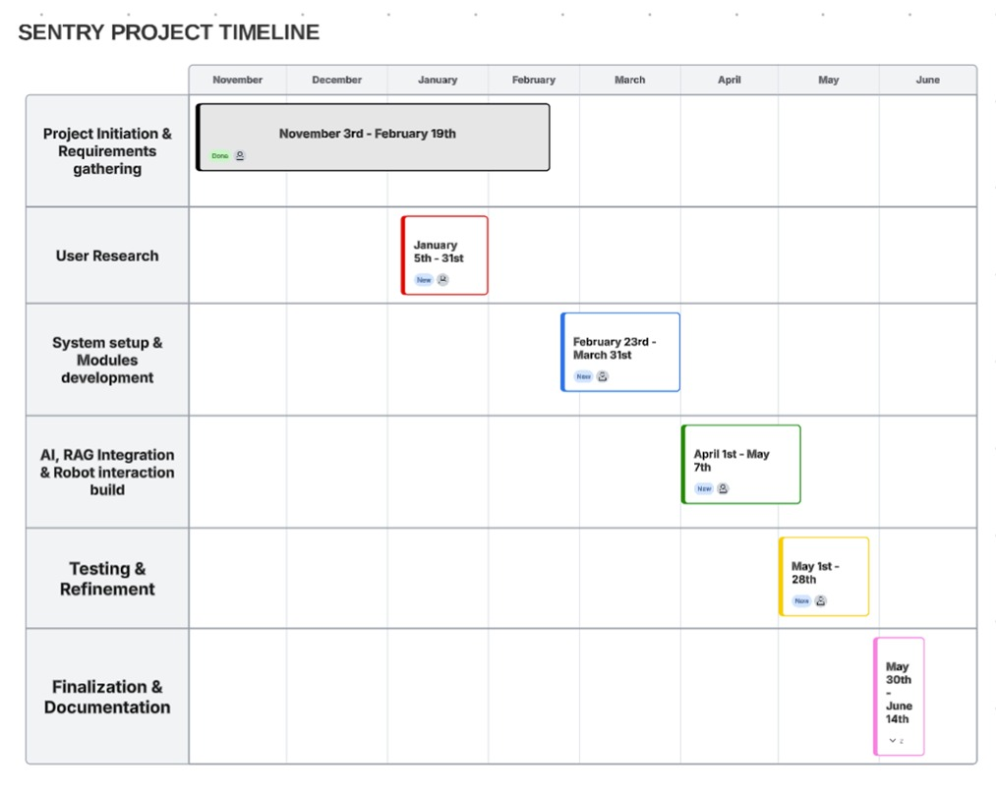

Appendix 1: Budget
Item | Description | Cost (KES)
Cloud API Credits | OpenAI GPT-4, Whisper API calls | 15,000
Vector DB Hosting | ChromaDB Cloud or Pinecone | 5,000
TOTAL |  | 20,000

